INT333 PROJECT

**AWS Instance Creation**

**Jenkins Server -Terminal 1**

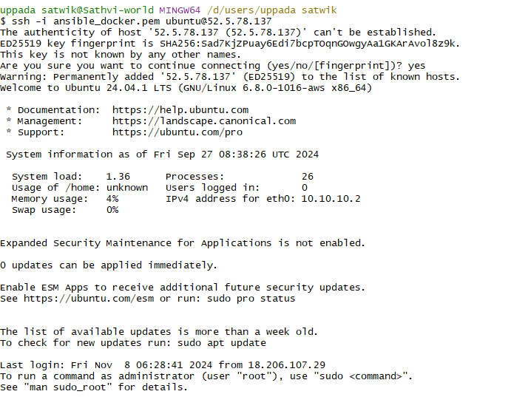

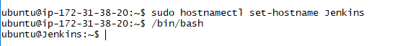

TO INSTALL JENKINS WE NEED JAVA-17

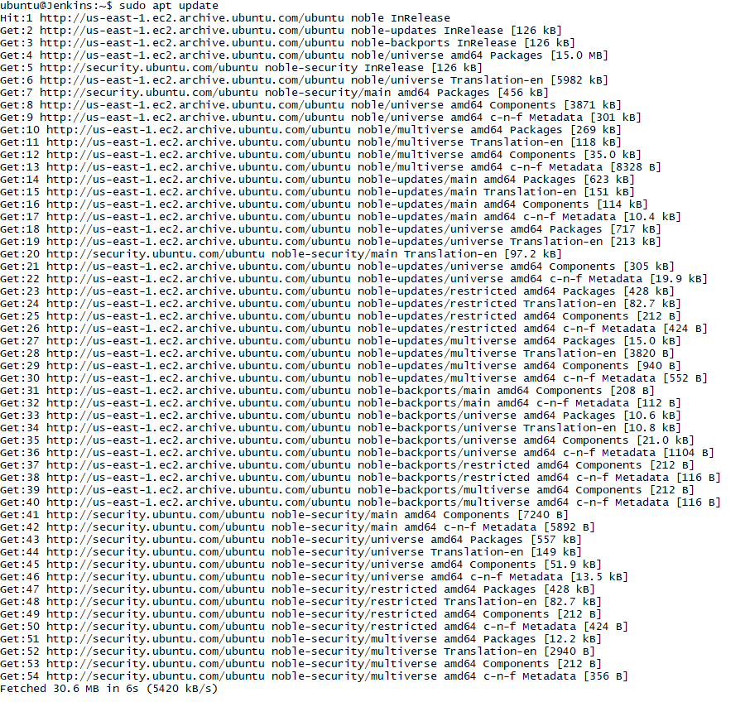

Update apt

1. Install java 🡪 sudo apt install openjdk-17-jre
2. Run these commands 🡪 (<https://www.jenkins.io/doc/book/installing/linux/>) Documentation for jenkins installation

sudo wget -O /usr/share/keyrings/jenkins-keyring.asc \

https://pkg.jenkins.io/debian-stable/jenkins.io-2023.key

echo "deb [signed-by=/usr/share/keyrings/jenkins-keyring.asc]" \

https://pkg.jenkins.io/debian-stable binary/ | sudo tee \

/etc/apt/sources.list.d/jenkins.list > /dev/null

sudo apt-get update

sudo apt-get install jenkins

1. Go to security groups 🡪 add inbound rule  
   custom TCP 🡪 8080 port 🡪 0.0.0.0/0 🡪 save the rules
2. After successful installation of jenkins. Copy your public ip address and paste on new tab   
   <public ip>:8080
3. You can see this webpage

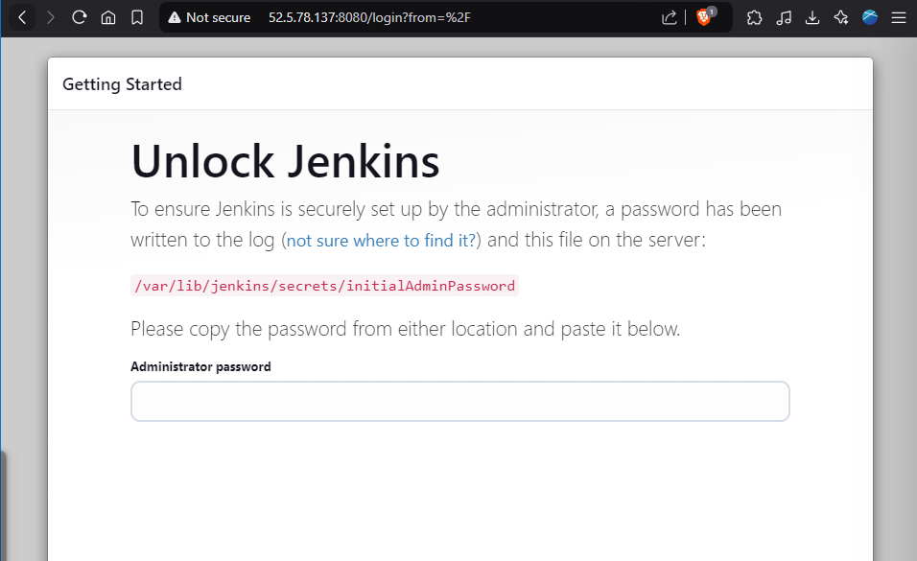

1. Check the status 🡪 the secret key will apper(highlighted one) 🡪 copy it and paste in administrator password
2. 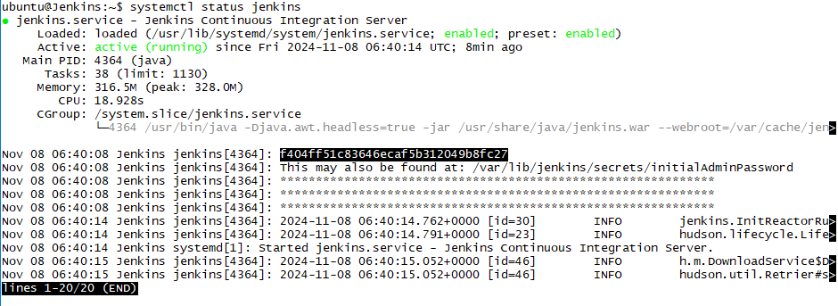

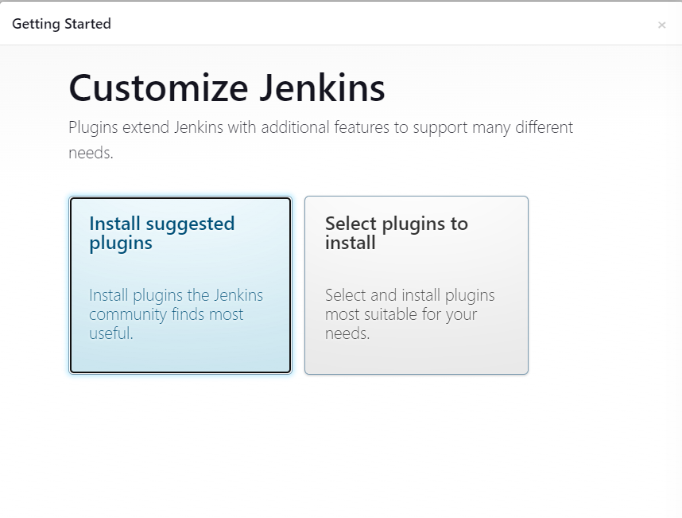

1. GO with install suggested plugings

Setup Ansible on Jenkins Server

1. Go to <https://docs.ansible.com/ansible/latest/installation_guide/installation_distros.html#installing-ansible-on-ubuntu>
2. Follow the commands

$ sudo apt update

$ sudo apt install software-properties-common

$ sudo add-apt-repository --yes --update ppa:ansible/ansible

$ sudo apt install ansible

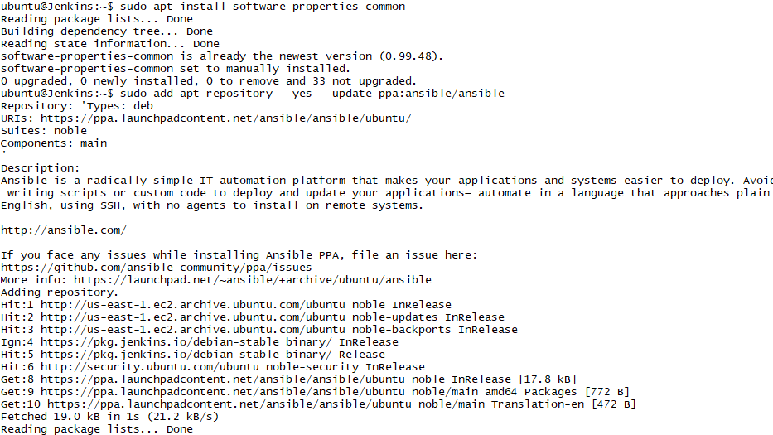

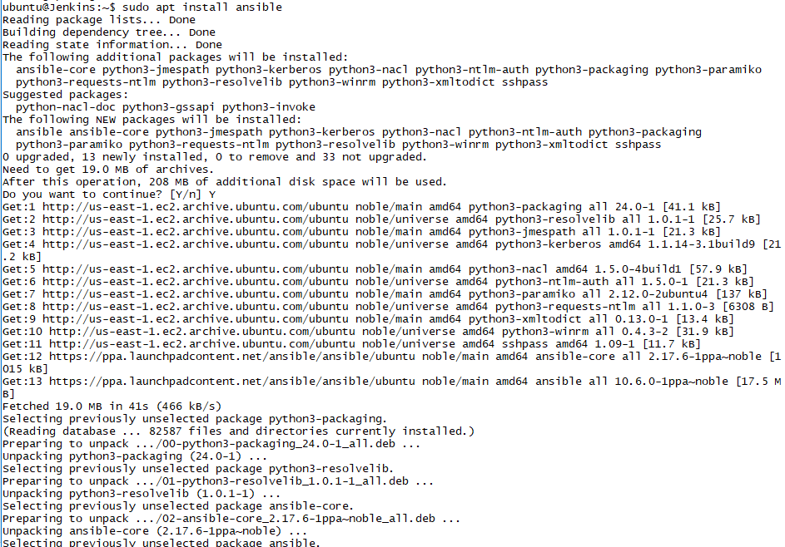

To run docker commands. We need to install docker on jenkins

1. sudo apt install python3-pip
2. sudo apt install python3-docker
3. 
4. sudo nano hosts 🡪 add docker server public ip here 🡪 follow the below image.
5. 
6. cd ~ 🡪 home folder
7. sudo su
8. su jenkins
9. 
10. Go to home directory of jenkins 🡪 cd ~
11. Create a folder called playbooks 🡪 mkdir playbooks
12. Create a ssh key for jenkins 🡪 ssh-keygen
13. Move to .ssh folder 🡪 cd .ssh/
14. We can find the public key file with .pub extension🡪 cat <filename> 🡪 copy the key and paste in authorized keys of docker server 🡪 go to terminal 2 and follow 16th command.
15. Once we paste the key 🡪 we can connect them using 🡪 ssh root@<docker server public ip>
16. 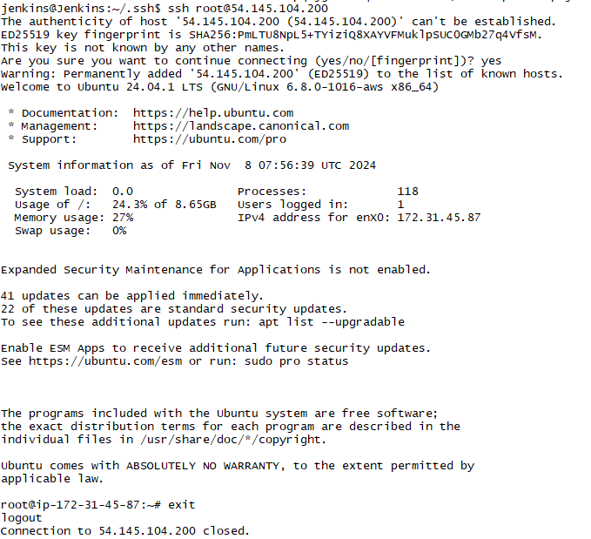You can see the connection of dockerr server private ip here
17. Exit the connected server 🡪 exit
18. Come out of .ssh and navigate to playbooks folder
19. cd ..
20. cd playbooks
21. nano deploymnt.yaml

- name: Build & deploy docker container

hosts: dockerservers

gather_facts: false

remote_user: root

tasks:

- name: Stopping the container

docker_container:

name: mico-container

image: mico:latest

state: stopped

- name: Removing the container

docker_container:

name: mico-container

image: mico:latest

state: absent

- name: Removing Docker Image

docker_image:

name: mico:latest

state: absent

- name: Building Docker Image

docker_image:

name: mico:latest

source: build

build:

path: ~/project/

state: present

- name: Creating the container

docker_container:

name: mico-container

image: mico:latest

ports:

- "80:80"

state: started

1. ctrl+s and ctrl+x
2. Create new jenkins pipeline

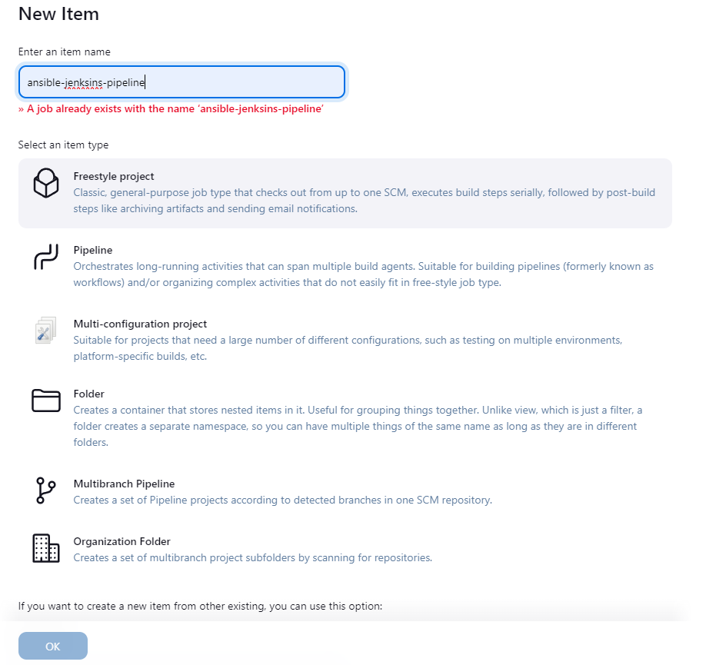

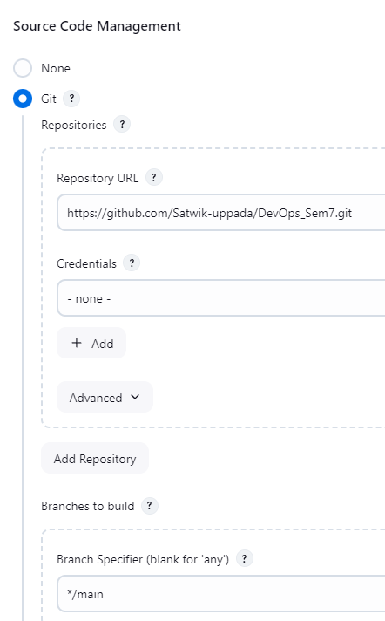

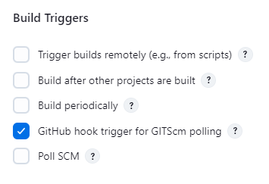

Go to github 🡪 project repository 🡪 settings 🡪 webhooks

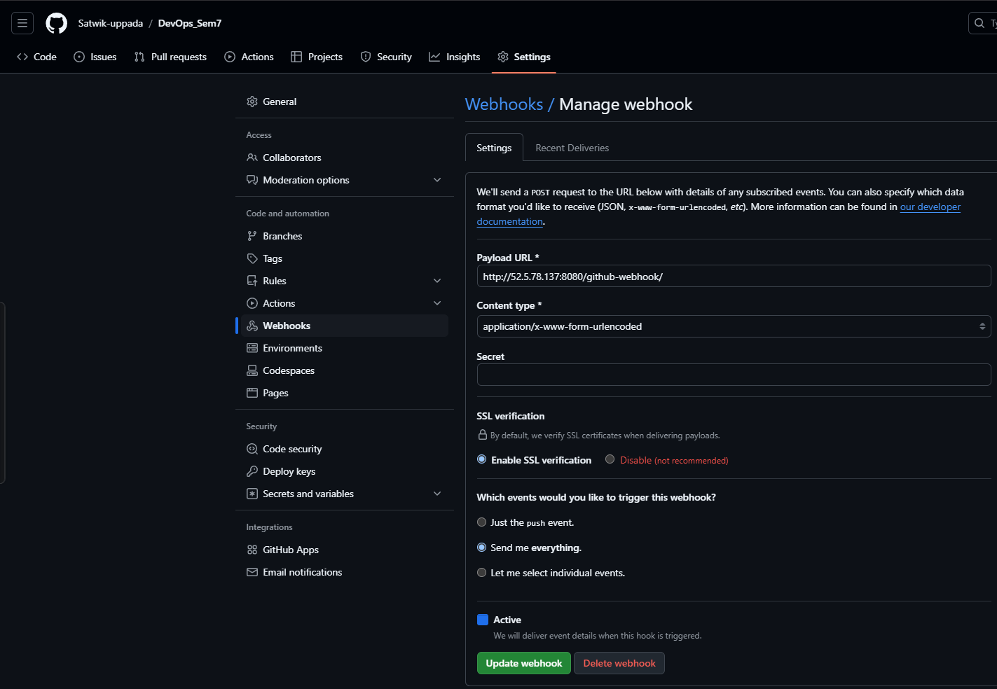

Payload url = <http://52.5.78.137:8080/github-webhook/>

52.5.78.137:8080 🡪 jenkins ip address

copy the path of files:

1. pwd 🡪 copy the path of playbooks and add on jenkins pipline 🡪 configure 🡪 build steps 🡪 add steps 🡪 add the paths
2. scp -r /var/lib/jenkins/workspace/ansible-jenksins-pipeline/* root@<public ip of docker server>:~/project

ansible-jenksins-pipeline 🡪 my pipeline name

1. ansible-playbook /var/lib/jenkins/playbooks/deployment.yaml
2. save it and build.
3. Make changes 🡪 it automatically builds and reflect on the ip address of docker server

**Docker server – Terminal 2**

Setting up docker server

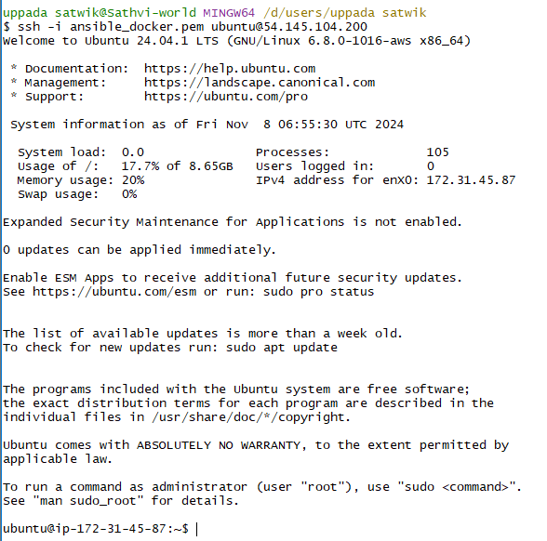

1. Sudo apt update
2. sudo apt-get update
3. sudo apt-get install docker.io
4. docker –version
5. 
6. We are not authenticated with docker
7. So, we need to add ubuntu user to docker 🡪 sudo usermod -aG docker ubuntu
8. Refresh the group 🡪 newgrp docker
9. Now try 🡪 docker ps 🡪 we wont get error
10. Log in to root user 🡪 sudo su
11. Create ssh key 🡪 ssh-keygen
12. Go to home directory 🡪 cd ~
13. ls -la 🡪 you can find .ssh folder
14. Go to .ssh folder 🡪 cd .ssh/
15. ls
16. You find **authorized_keys** file
17. Open it 🡪 nano authorized_keys
18. Add the key which we get it on jenkins server
19. Restart sshd 🡪 systemctl reload ssh
20. Bond the connection with jenkins server 🡪 go to terminal 1 and follow the 15th command

**Changes**

1. **I CHANGED THE CODE IN index.html. Jenkins automatically recognized and building**

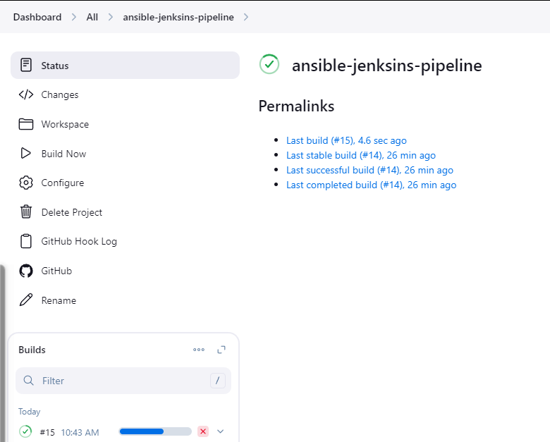





Sshkey 🡪 ssh-ed25519 AAAAC3NzaC1lZDI1NTE5AAAAIHcx8epqCjgf77TRqabuW09OFM9MQK6f4XnXp0l1AXep jenkins@Jenkins

Jenkins key 🡪 f404ff51c83646ecaf5b312049b8fc27